SEMESTER TWO
Papers written by
Australian Maths Software

YEAR 12
MATHEMATICS METHODS
Units 3-4
2017
Section Two
(Calculator–assumed)

Name: _________________________________

Teacher: ________________________________

TIME ALLOWED FOR THIS SECTION

Reading time before commencing work: 10 minutes
Working time for section: 100 minutes

MATERIAL REQUIRED / RECOMMENDED FOR THIS SECTION

To be provided by the candidate
Standard items: pens, pencils, pencil sharpener, highlighter, eraser, ruler.

Special items: drawing instruments, templates, notes on up to two unfolded sheet of A4 paper, and up to three calculators approved for use in the WACE examinations.

IMPORTANT NOTE TO CANDIDATES

No other items may be taken into the examination room. It is your responsibility to ensure that you do not have any unauthorised notes or other items of a non–personal nature in the examination room. If you have any unauthorised material with you, hand it to the supervisor before reading any further.

To be provided by the supervisor

Question/answer booklet for Section Two.
Formula sheet retained from Section One.
Structure of this examination

 | Number of questions available | Number of questions to be answered | Working time (minutes) | Marks available | Percentage of exam
Section One  Calculator—free | 8 | 8 | 50 | 52 | 35
Section Two  Calculator—assumed | 12 | 12 | 100 | 98 | 65
Total marks |  |  |  | 150 | 100

Instructions to candidates

1. The rules for the conduct of this examination are detailed in the Information Handbook.
Sitting this examination implies that you agree to abide by these rules.

2. Write your answers in the Question/Answer booklet.

3. You must be careful to confine your responses to the specific questions asked and to
follow any instructions that are specific to a particular question.

4. Spare pages are provided at the end of this booklet. If you need to use them, indicate
in the original answer space where the answer is continued i.e. give the page number.

5. Show all your working clearly. Your working should be in sufficient detail to allow your answers to be checked readily and for marks to be awarded for reasoning. Incorrect answers given without supporting reasoning cannot be allocated any marks. For any question or part question worth more than two marks, valid working or justification is required to receive full marks. If you repeat an answer to any question, ensure that you cancel the answer you do not wish to have marked.

6. It is recommended that you do not use pencil, except in diagrams.

7. The Formula Sheet is not to be handed in with your Question/Answer booklet.

9. (6 marks)

(a) Use your calculator to complete the table below (2)

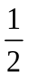
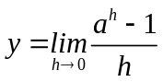

(b) Plot the data in the table above on the set of axes below. (2)

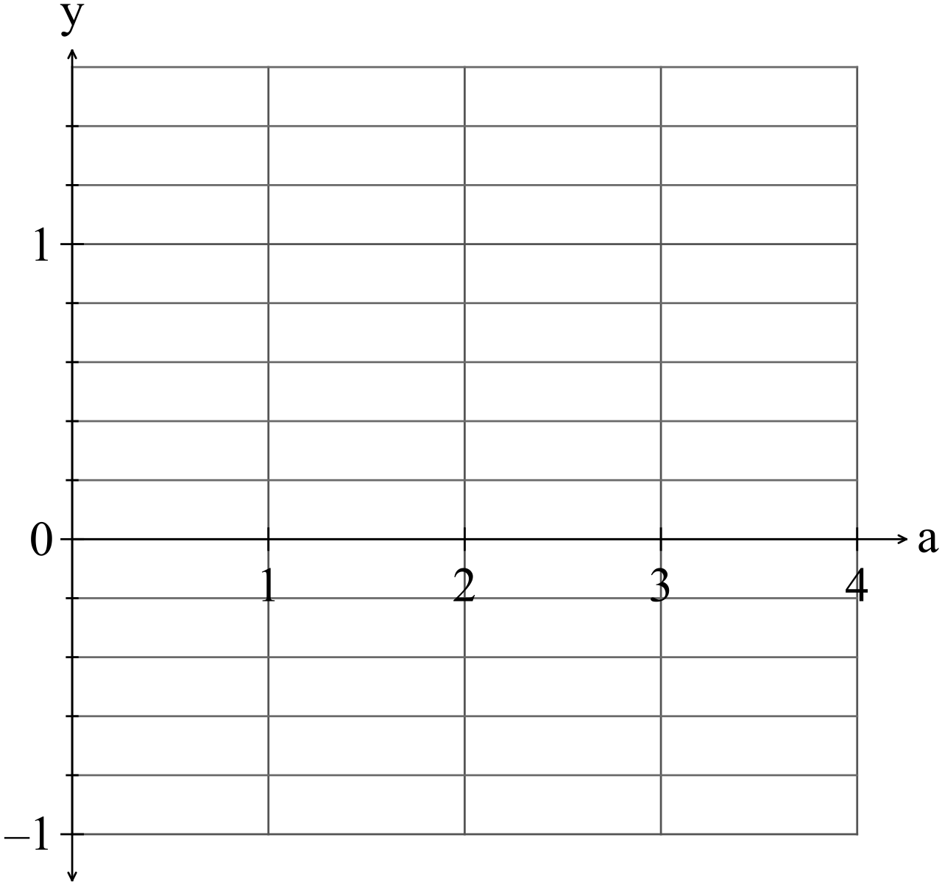

(c) Write down the equation of the function graphed in (b). (1)

(d) Determine such that 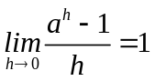. (1)

10. (7 marks)
The number of people who have the flu in the first three weeks of an epidemic can be
modelled by the equation 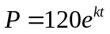 where is measured in days and 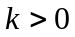.
Initially, the number of people who had the flu was 120.

After 10 days, 250 people had the flu.
(a) Determine the value of k. (1)

(b) After how many days would you expect 300 people to be infected? (1)

(c) Determine how fast the flu is spreading after one week. (2)

(d) How fast is the rate of infection increasing after one week? (2)

(e) Briefly explain why the model cannot be used indefinitely. (1)


11. (5 marks)
Given 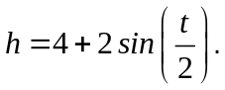
find
(a) at 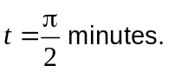 (1)

(b) such that 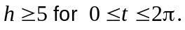 (1)

(c) 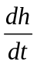 at 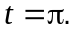 (1)

(d) 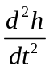 at 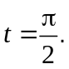 (2)

12, (4 marks)
A pizza is 30 cm in diameter. Josh asks for a piece in the shape of a sector that makes
an angle of 30º at the centre of the pizza. His piece is 0.5 cm high.
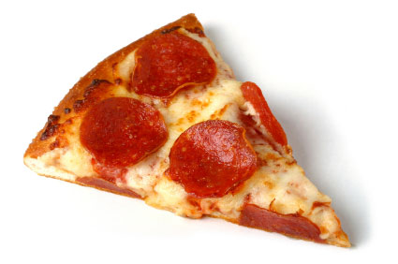
Josh is given a piece of pizza that makes an angle of 33º at the centre of the pizza.

(a) Write down the formula for the volume of a piece of pizza in the shape on a sector
in cm³, (1)

(b) Use a calculus method to determine the extra volume of pizza Josh is given. (3)

13. (14 marks)
(a) The number of amoeba in a petri dish is given by 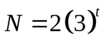 where is given in
hours.
(a) (i) Complete the following table. (2)

t | N
1 | 6
2
3
4
5

(ii) Complete the table below that uses 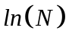instead of . (2)

t | ln(N)
1
2
3
4
5

(iii) Plot the data in (b) on the set of axes below. (2)

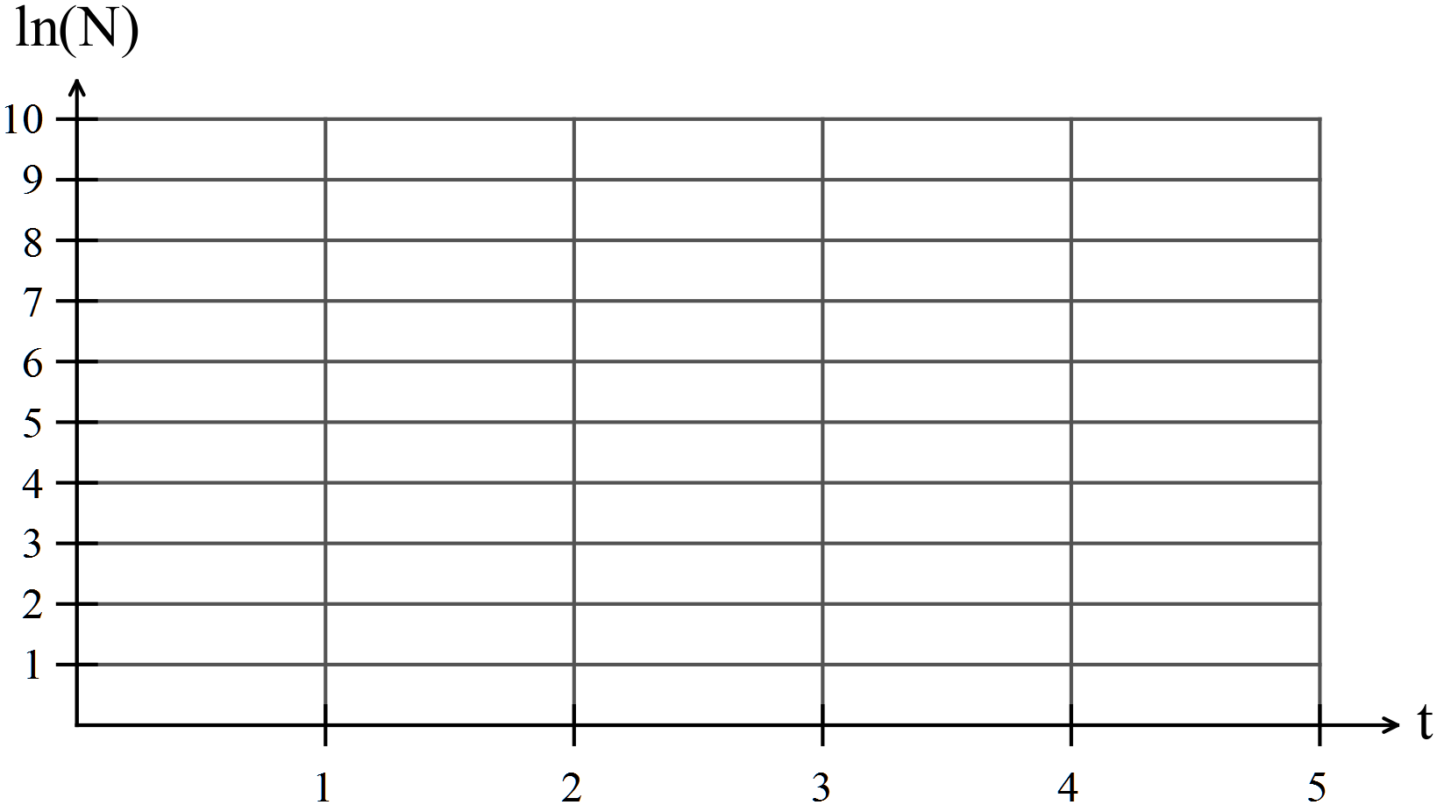

(iv) Explain the advantage of plotting ln(N) against t instead of N against t. (2)

(b) Given the graph of 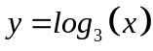 sketch 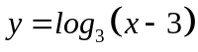on the same set of axes.
(2)

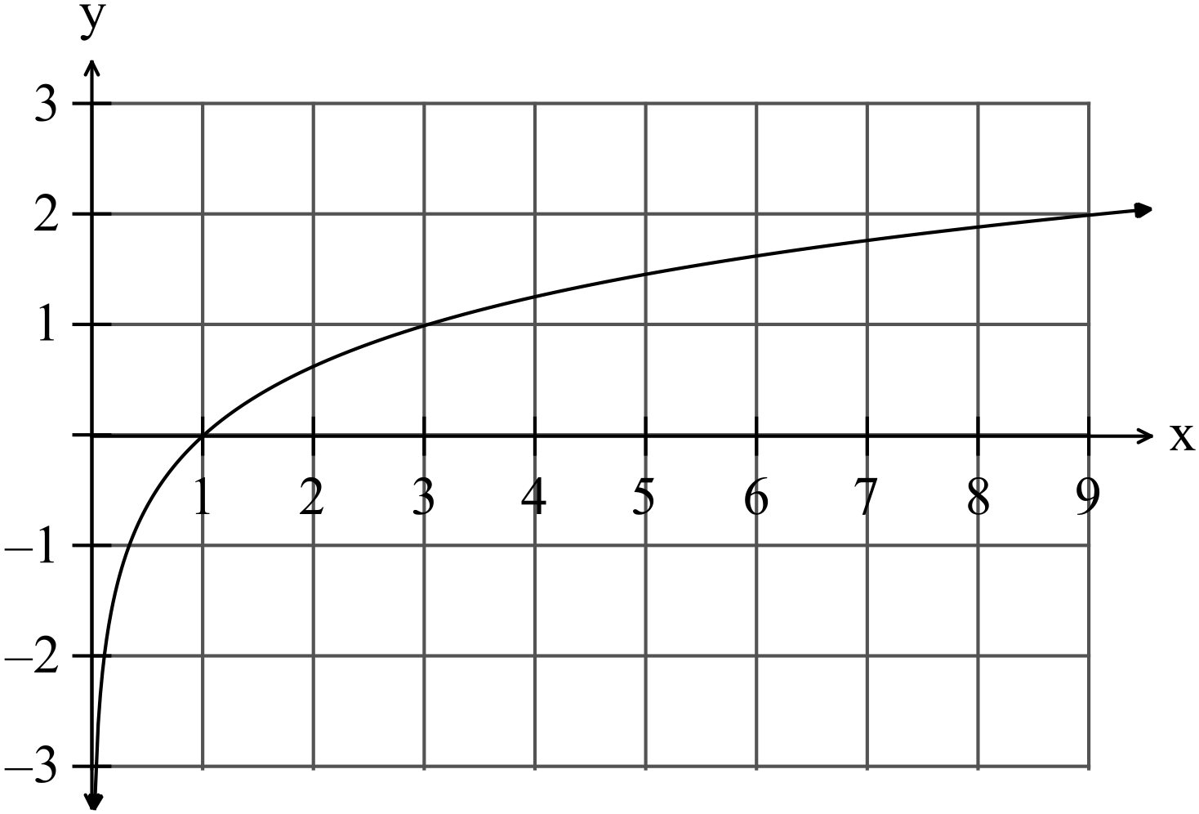

(c) Solve for x :
(i) 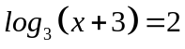 (2)

(ii) 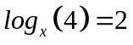 (2)

14. (6 marks)
The displacement of a particle is given by 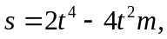 for 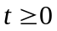
where is in seconds.
Determine
(a) the velocity when the displacement is zero for 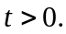 (3)

(b) The velocity of a particle is given by 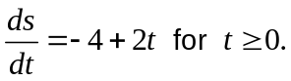
If the initial displacement is 1 m. find the displacement and acceleration
when 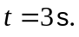 (3)

15. (5 marks)
(a) Determine the area bounded by the functions 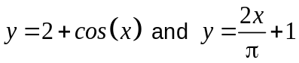 and the axis in the diagram below.

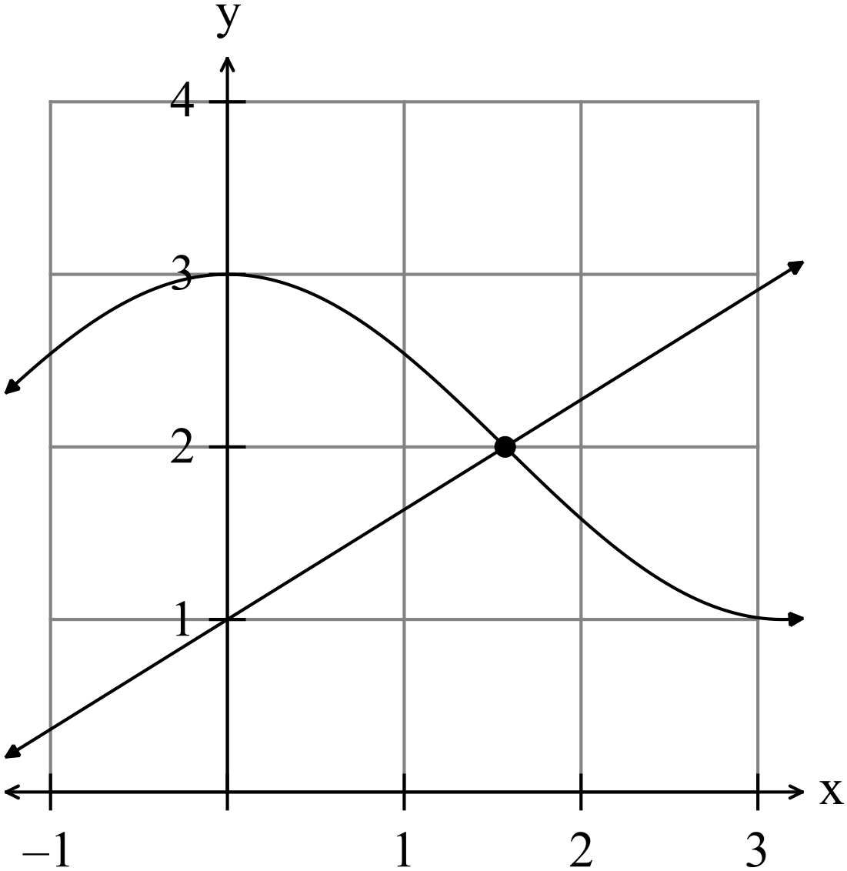
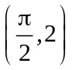

(2)

(b) Determine the shaded area in the diagram below for 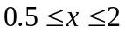 .
The integral of some bounded regions for each function are given. (3)

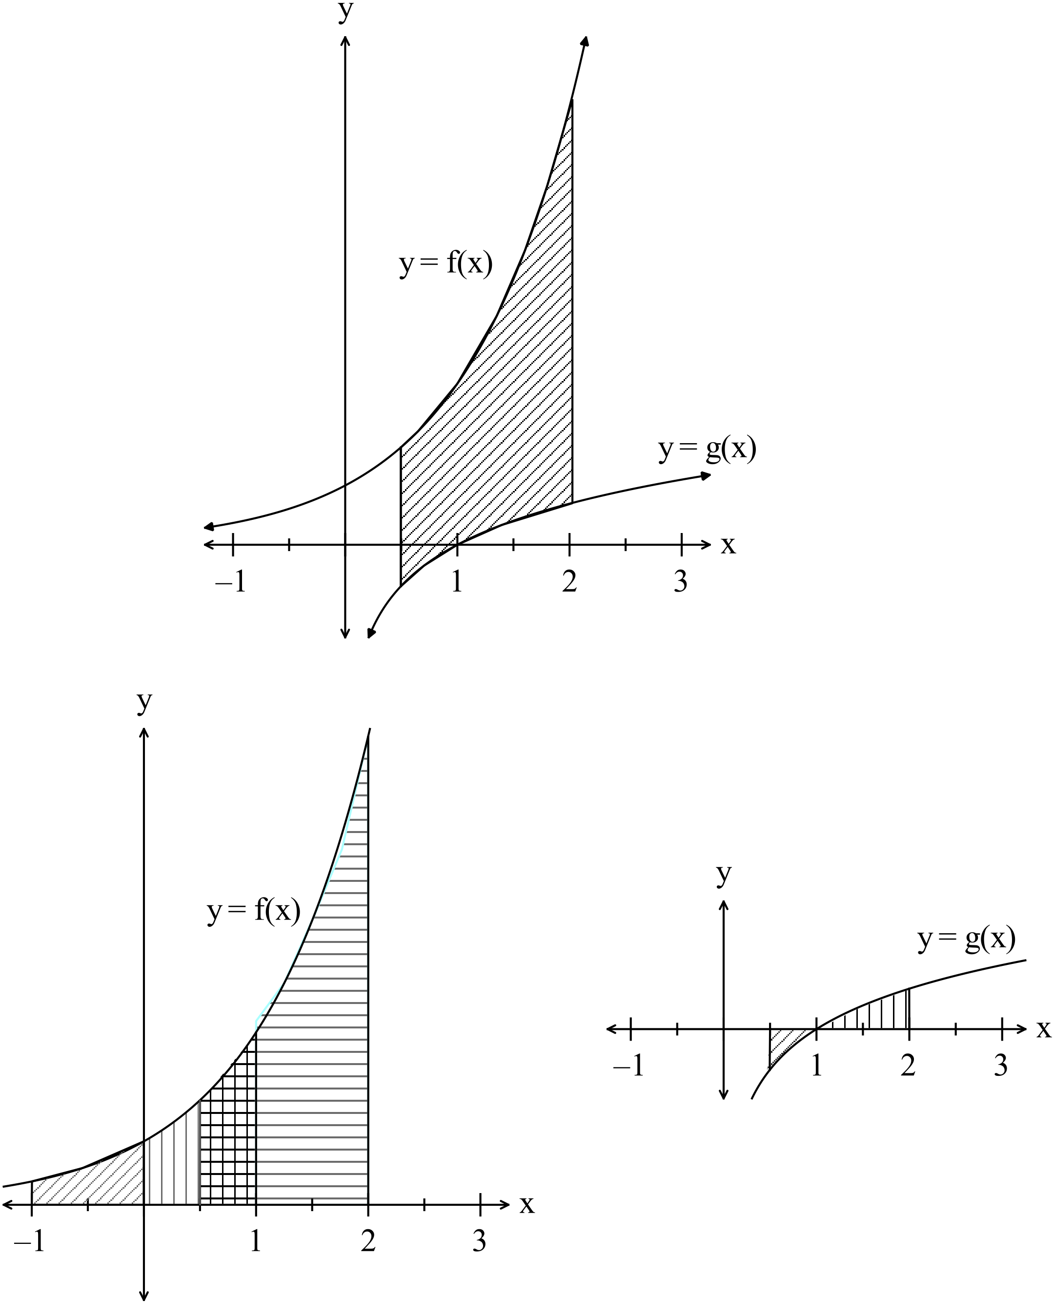

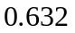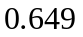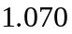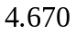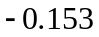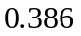

16. (5 marks)

Consider the rectangle ABCP in the diagram below.

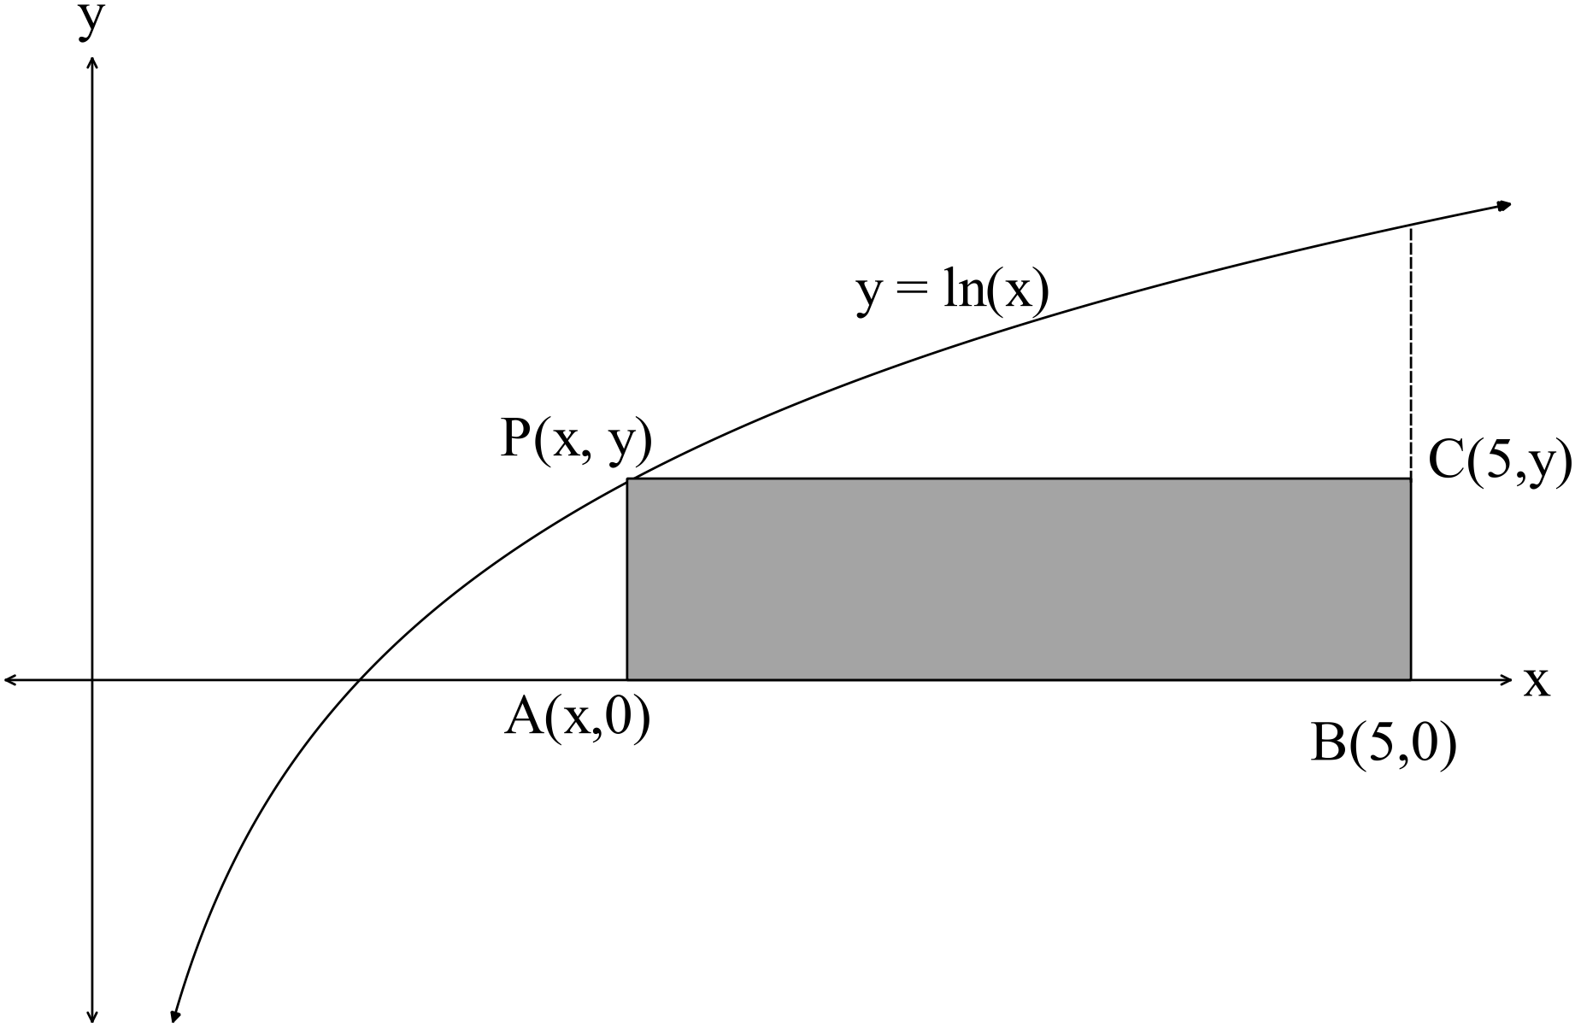

The rectangle is bounded by the axis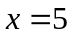and one vertex 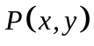lies on the
function 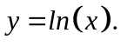
Find the coordinates of point  such that the area of the rectangle is maximised. (5)
17. (12 marks)

(a) The heights attained by a variety of a small flowering tree are normally
distributed with an average height of 3.5 m and a standard deviation of 0.5 m.
Joan planted one of the trees under a second storey window the base of which
is 4 m above the ground.

(i) What are the chances the tree will reach more than 4 m? (1)

(ii) What are the chances the tree will grow no more than 0.5 m above the
base of the window if it has already reached 4 m in height? (2)

Joan planted four of the trees one metre from the house.
(iii) What is the probability that at least three of them grow to more than 4 m?
(2)

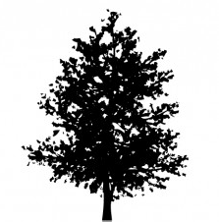

(b) Three hundred 4 child families were surveyed to estimate the number of families
expected to have 0, 1, 2, 3 or 4 girls in the family.
The results are in the table below

Number of girls in the family | Frequency
0 | 20
1 | 80
2 | 110
3 | 74
4 | 16

(i) Complete the chart below using the data in the table.
 is the set of numbers that represents the number of girls in a
4 child family.

x | 0 | 1 | 2 | 3 | 4
P(X = x)

(2)
(ii) Calculate the theoretical probabilities to complete the table below.

x | 0 | 1 | 2 | 3 | 4
P(X = x)
(2)

Deterrmine the theoretical probabilities below.

(iii) 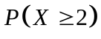 (1)

(iv) 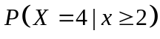 (2)

18. (8 marks)
Only 30% of cars have the petrol cap on the driver’s side of the car.
Eight cars drove into a petrol station to top up their petrol.

(a) What is the probability that three of the cars had the petrol cap on the
driver’s side of the car? (2)

(b) What is the probability that no more than three of the cars had the petrol
cap the driver’s side of the car? (2)

(c) What is the probability that none of the cars had the petrol cap on the
driver’s side of the car? (2)

(d) Given the first three cars had petrol caps on the driver’s side of the car,
what is the probability that the last five cars had their petrol cap on the
other side of the car? (2)

19. (14 marks)
The continuous random variable has the probability density function

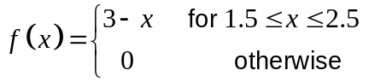
(a) Prove that  represents a probability density function. Show all steps. (3)

(b) Determine 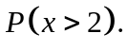 (2)

(c) Determine 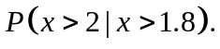 (2)

(d) Write down the expressions that if evaluated gives the expected value. (2)

(e) Find a simplified expression for the cumulative probability density function.
(3)

(f) Using the simplified expression for the cumulative probability density function
determine 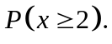 (2)

20. (12 marks)
(a) One hundred and forty out of a sample of 200 Shenton Park ratepayers do not
want Shenton College moved to the Perth CBD.
Within what range of percentages of ratepayers can we be 95% confident that
the ratepayers of Shenton Park do not want Shenton College moved to Perth
CBD? (5)
HINT: Use 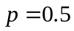 to ensure valid confidence limits.

(b) In WA the probability of those in favour of raising the age to 18 when a person
can obtain a driving license is unknown.
What sample size should be used to estimate the probability of those in favour of
raising the age to 18 to get a driver’s license with an error margin of 10%
and a confidence level of 95%? (5)

(c) If the confidence level in (b) is 90% instead of 95% would the sample size be
smaller or larger? Explain. (2)

END OF SECTION TWO
Extra page for working if necessary

